# Archivo:Logo Instituto Politécnico Nacional.png - Wikipedia, la enciclopedia libreArchivo:EscudoESCOM.png - Wikipedia, la enciclopedia libreINSTITUTO POLITÉCNICO NACIONAL

# ESCUELA SUPERIOR DE CÓMPUTO

Vargas Hernández Carlo Ariel

Análisis de algoritmos

3CM15

Ejercicios 01



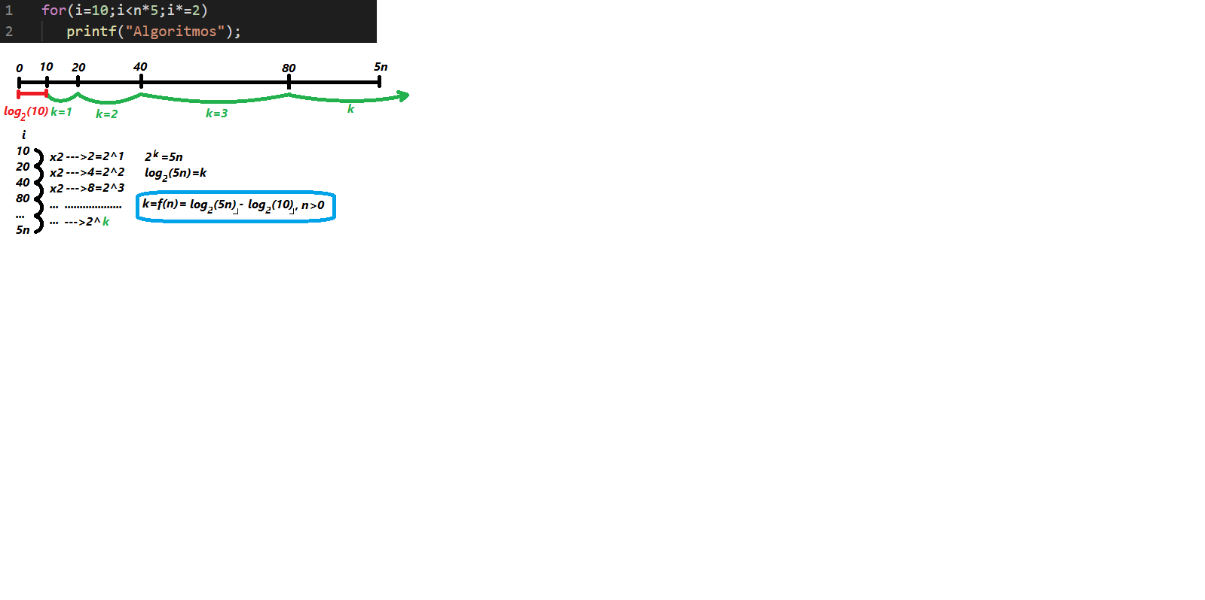**Problema 1:**

|  |  |  |
| --- | --- | --- |
| n | Valor de la formula | Valor del programa |
| -1 | --- (#¡NUM!) | 1 |
| 0 | ----- | 1 |
| 1 | -3 | 1 |
| 2 | -2 | 1 |
| 3 | -2 | 2 |
| 5 | -1 | 3 |
| 15 | 0 | 4 |
| 20 | 1 | 5 |
| 100 | 3 | 7 |
| 409 | 5 | 9 |
| 500 | 5 | 9 |
| 593 | 6 | 10 |
| 1000 | 6 | 10 |
| 1471 | 7 | 11 |
| 1500 | 7 | 11 |
| 2801 | 8 | 12 |
| 3000 | 8 | 12 |
| 5000 | 9 | 13 |
| 10000 | 10 | 14 |
| 20000 | 11 | 15 |
|  |  |  |

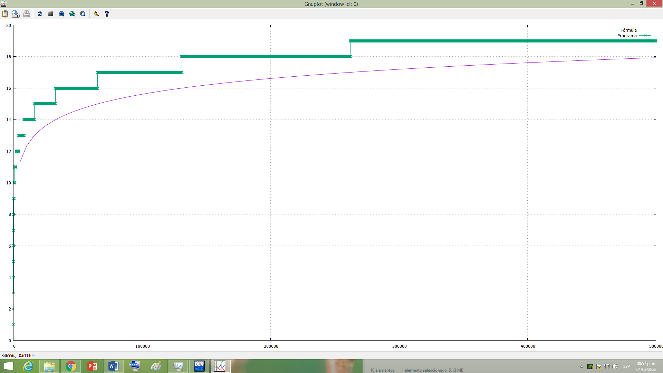

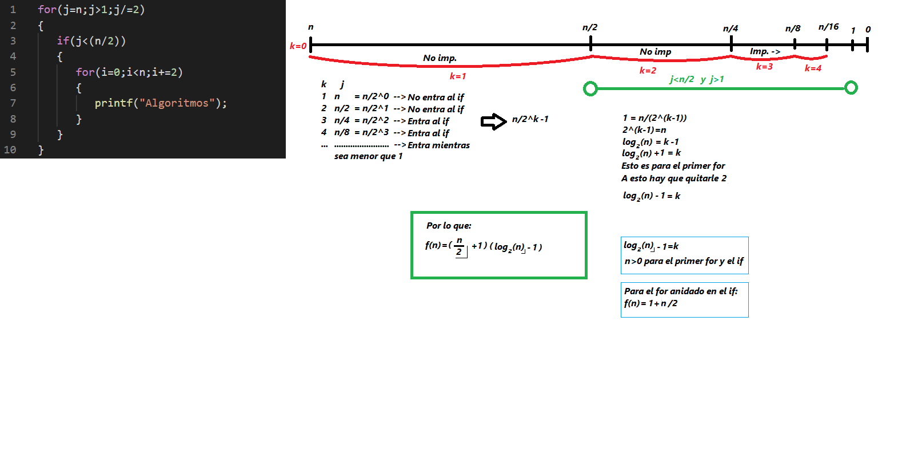**Problema 2:**



|  |  |  |
| --- | --- | --- |
| n | Valor de la formula | Valor del programa |
| -1 | --- | 1 |
| 0 | ----- | 1 |
| 1 | -1 | 1 |
| 2 | 0 | 1 |
| 3 | 0 | 1 |
| 5 | 3 | 4 |
| 15 | 16 | 17 |
| 20 | 33 | 31 |
| 100 | 255 | 251 |
| 409 | 1435 | 1436 |
| 500 | 1757 | 1751 |
| 593 | 2376 | 2377 |
| 1000 | 4008 | 4001 |
| 1471 | 6624 | 6625 |
| 1500 | 6759 | 6751 |
| 2801 | 14010 | 14011 |
| 3000 | 15010 | 15001 |
| 5000 | 27511 | 27501 |
| 10000 | 60012 | 60001 |
| 20000 | 130013 | 130001 |

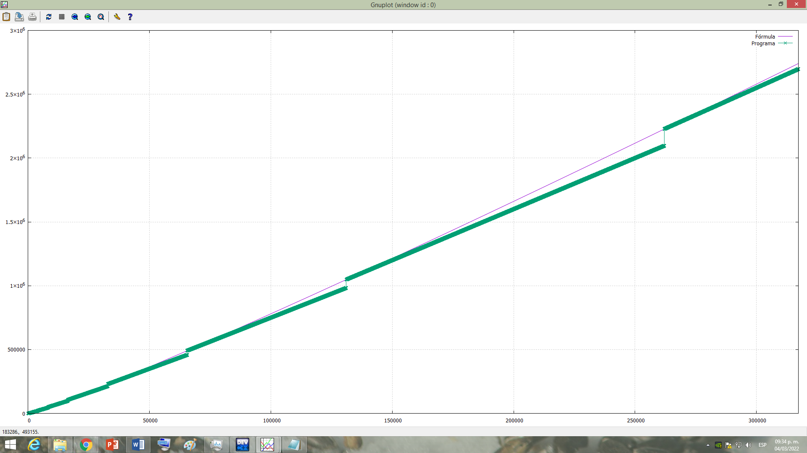

**Problema 3:**

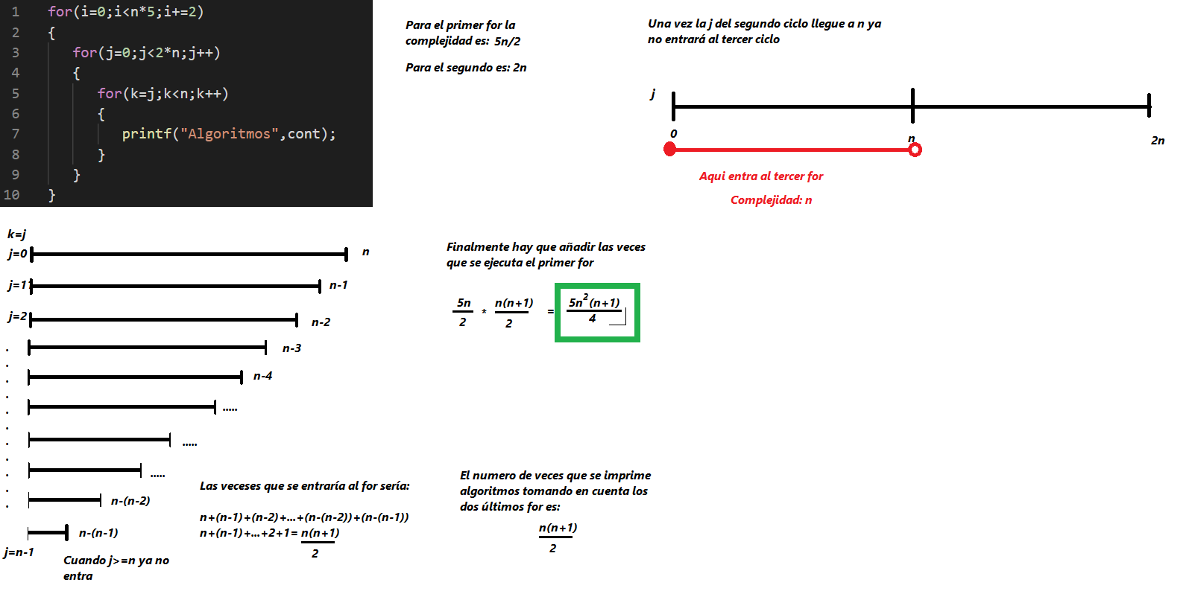





|  |  |  |
| --- | --- | --- |
| n | Valor de la formula | Valor del programa |
| -1 | 0 | 1 |
| 0 | 0 | 1 |
| 1 | 2 | 4 |
| 2 | 15 | 16 |
| 3 | 45 | 49 |
| 5 | 187 | 196 |
| 15 | 4500 | 4561 |
| 20 | 10500 | 10501 |
| 100 | 1262500 | 1262501 |
| 409 | 85731512 | 85773436 |
| 500 | 156562500 | 156562501 |
| 593 | 261099382 | 261187444 |
| 1000 | 1251250000 | 1251250001 |
| 1471 | 3981467440 | 3982008769 |
| 1500 | 4221562500 | 4221562501 |
| 2801 | 2.7479E+10 | 27481179604 |
| 3000 | 3.3761E+10 | 33761250001 |
| 5000 | 1.5628E+11 | 156281250001 |
| 10000 | 1.2501E+12 | Ya era muy grande y se tardó mucho |
| 20000 | 1.0001E+13 | Ya era muy grande y se tardó mucho |

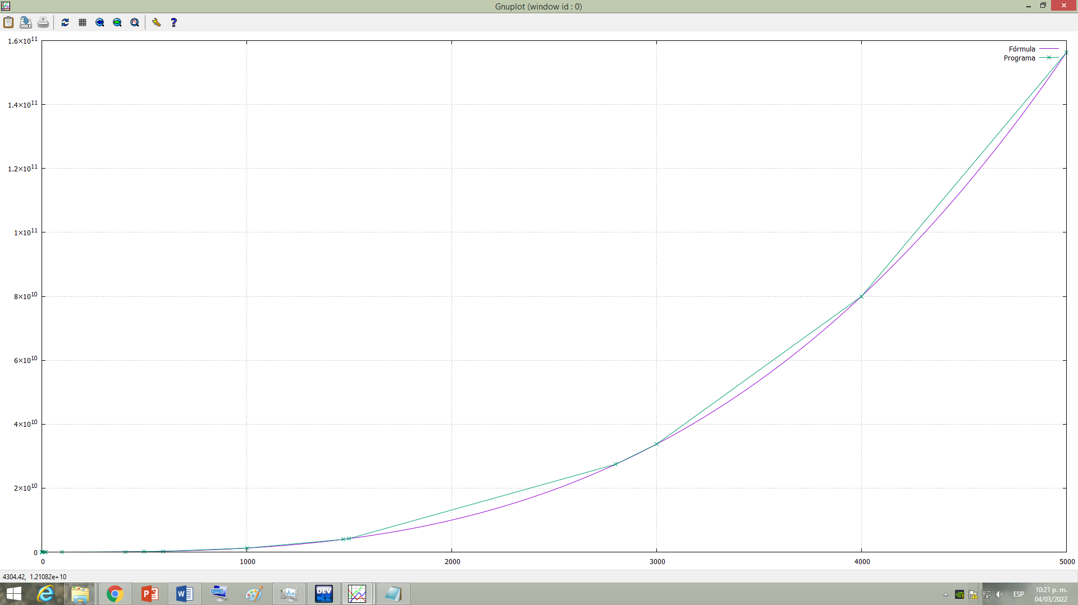

Fue hasta 5 mil por cuestión de tiempo

**Problema 4:**

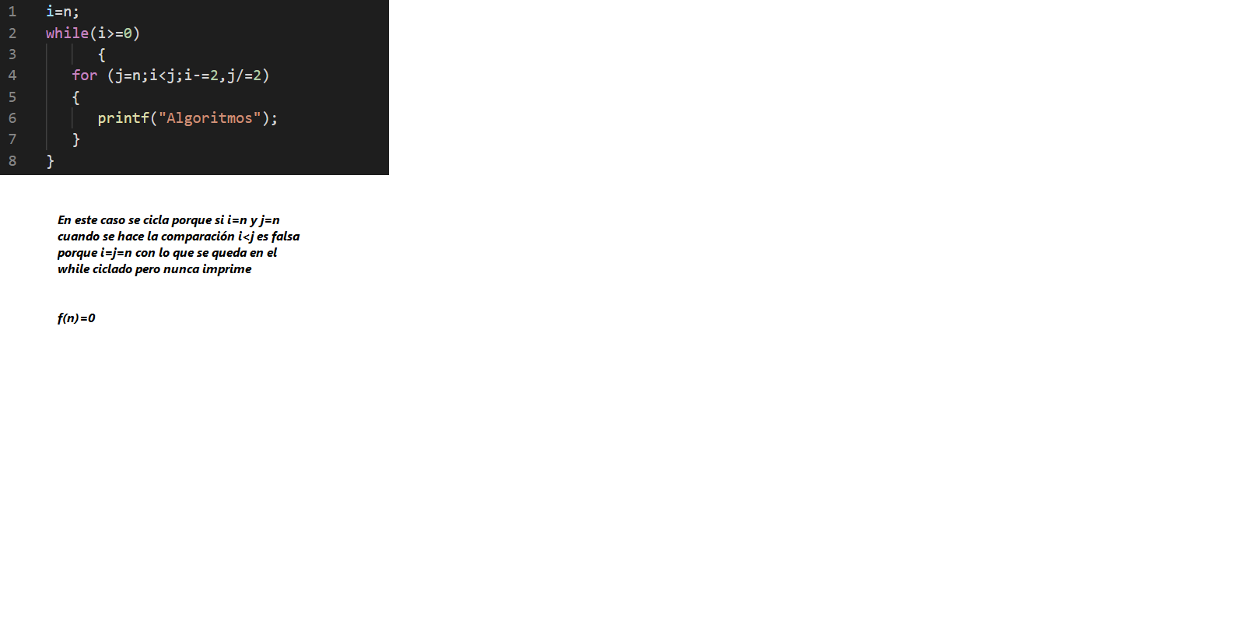



|  |  |  |
| --- | --- | --- |
| n | Valor de la formula | Valor del programa |
| -1 | 0 | 0 |
| 0 | 0 | 0 |
| 1 | 0 | 0 |
| 2 | 0 | 0 |
| 3 | 0 | 0 |
| 5 | 0 | 0 |
| 15 | 0 | 0 |
| 20 | 0 | 0 |
| 100 | 0 | 0 |
| 409 | 0 | 0 |
| 500 | 0 | 0 |
| 593 | 0 | 0 |
| 1000 | 0 | 0 |
| 1471 | 0 | 0 |
| 1500 | 0 | 0 |
| 2801 | 0 | 0 |
| 3000 | 0 | 0 |
| 5000 | 0 | 0 |
| 10000 | 0 | 0 |
| 20000 | 0 | 0 |

